Debugging and ATMELStudio
https://www.youtube.com/watch?v=wQZKWgnmvQ8

Table of Contents
1 Debugging and ATMELStudio 1
1.1 Video Tutorial 1
1.2 New Project 1
1.3 Debug Windows 2
1.4 Debug Commands 3
1.5 Breakpoints and Tracepoints 4
1.6 Stimulifile 4
1.7 Conditional Compiling 6

Video Tutorial
{TEXTBOX:video}

New Project
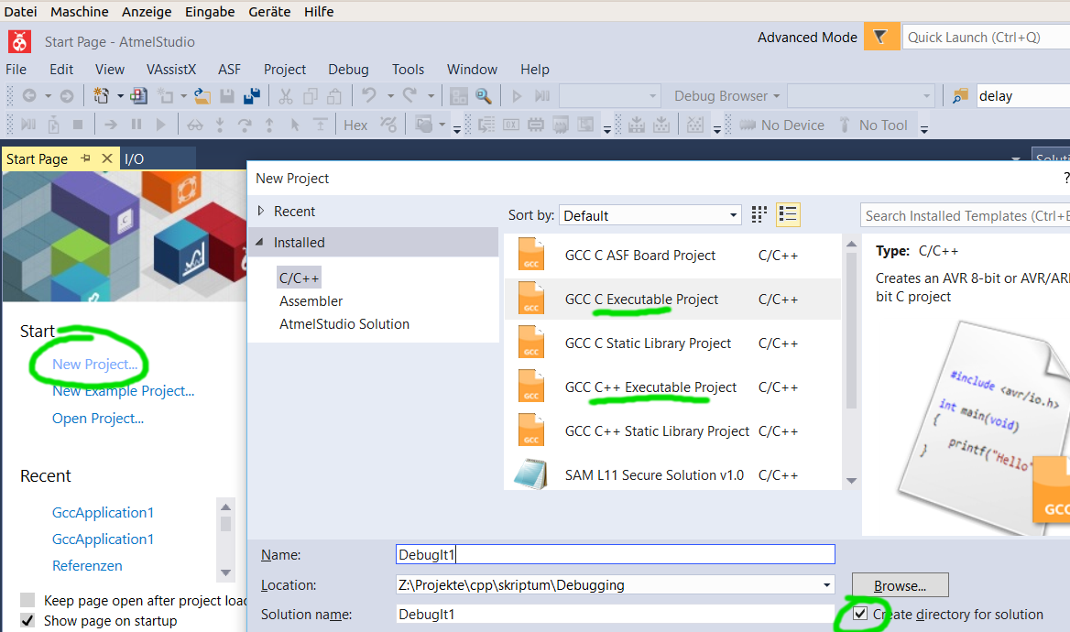Select your Processor (e.g. Atmega328p)

Properties
Menu //Project/Properties

Toolchain
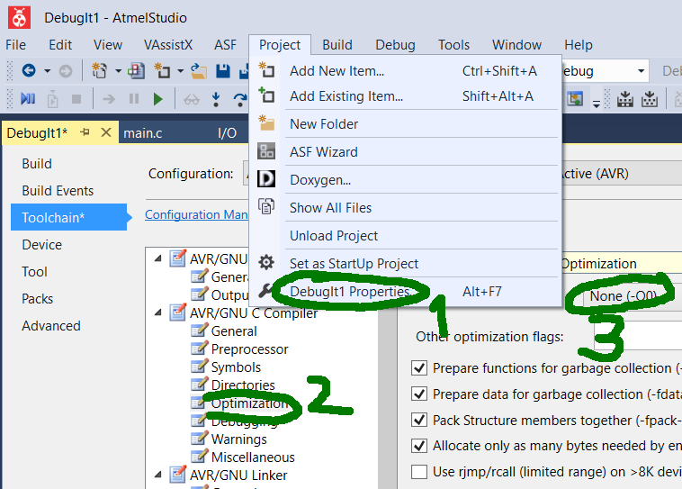

Simulator
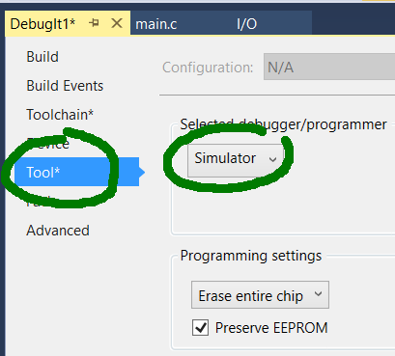

Debug Windows

Watch
Shows Variables, Add Watch to control value and address
Edit in Watch Window to output in various formats e.g. PINB,d to display char* text1 = ″Hallo″; use text1, s in Watch window
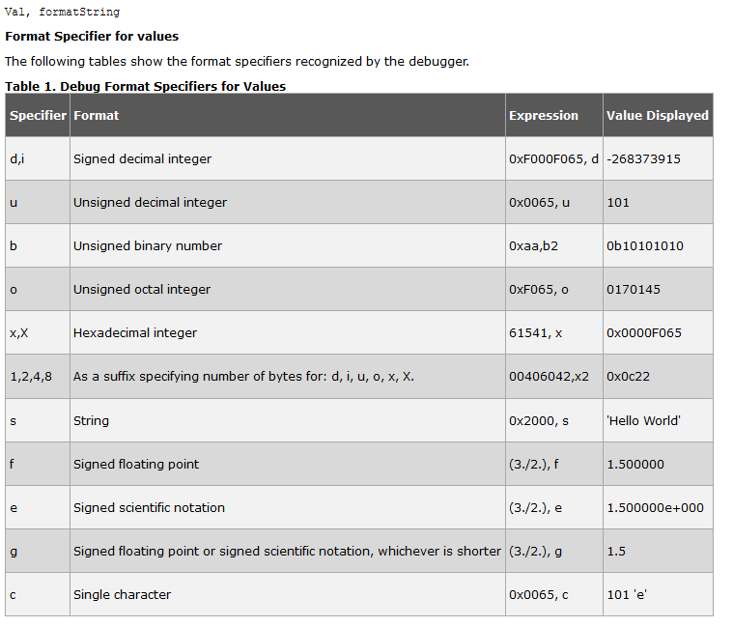

IO
Shows IO Devices
Add multiple IO devices by CTRL+Click

Processor Status
Shows Registers and Processor Cycles/Stopwatch
Dialog to control simulation clock frequency
Reset stopwatch/cycle counter (right click)

Memory
Display and Edit Memory Content

Disassembly
Display OpCode

Debug Commands
- Run
run to next break point
- Step Over
step functions as one line of code
- Step Into
step into functions
- Step Out
step one level up
- Reset
like hardware reset
- Break
break to later continue
- Stop
stop simulation (source code changed)

Breakpoints and Tracepoints

Breakpoint
Start Debugging and Break
Breakpoint/Insert Breakpoint/Toggle Breakpoint or Double Click on left gray window frame

Conditional Breakpoint
set a condition and display a message when breakpoint was hit
stop execution

Tracepoint
set a message when tracepoint was hit
continue execution; needed to trace program execution (wherever I've been)

Data Breakpoint
use a static variable (heap address) and monitor its state; control number of hits of this breakpoint by right click on the databreakpoint

Stimulifile
A stimuli file (name.stim) is used to change PIN inputs, log information und stop execution automatically.

Set Stimulus File and execute it
1. Set Stimulus File in Project/Preferences
2. //Debug/Start Debugging and Break
3. //Debug/Execute Stimulifile
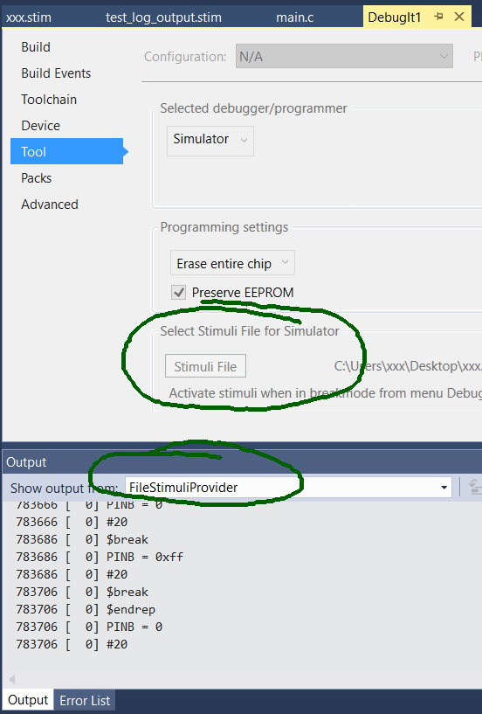

Stimulifile example

Example 1
//sets port B, waits 20 cycle and stops execution – resum it
$repeat 2000000
PINB = 0
#20
$break
PINB = 0xff
#20
$break
$endrep

Example 2
write a logfile

$log PORTB
$log PINB
$log SP
$startlog logfile.stim
$reset
PINB = 0x55
#10
PORTB = 0x99
#10
$break
PORTB |= 0xFF
#10
$stoplog
$break

Conditional Compiling
Another method for debugging is the use of a display/serial port and conditional compiling. The symbol DEBUG is set automatically when in Debug perspective.
#ifdef DEBUG
Serial.write(x);
#endif

